FINDING TIME COMPLEXITY OF ALGORITHMS

Problem 1: Finding Complexity using Counter Method

Convert the following algorithm into a program and find its time complexity using the counter method.
void function (int n)
{
int i= 1;
int s =1;
while(s <= n)
{
i++;
s += i;
}
}
Note: No need of counter increment for declarations and scanf() and count variable printf() statements.
Input:
A positive Integer n
Output:
Print the value of the counter variable

For example:
Input | Result
9 | 12
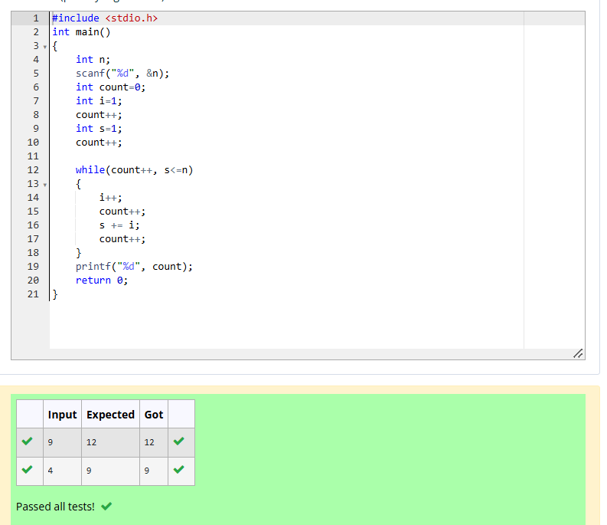

Problem 2: Finding Complexity using Counter method
Convert the following algorithm into a program and find its time complexity using the counter method.
void func(int n)
{
if(n==1)
{
printf("*");
}
else
{
for(int i=1; i<=n; i++)
{
for(int j=1; j<=n; j++)
{
printf("*");
printf("*");
break;
}
}
}
}

Note: No need of counter increment for declarations and scanf() and count variable printf() statements.
Input:
A positive Integer n
Output:
Print the value of the counter variable

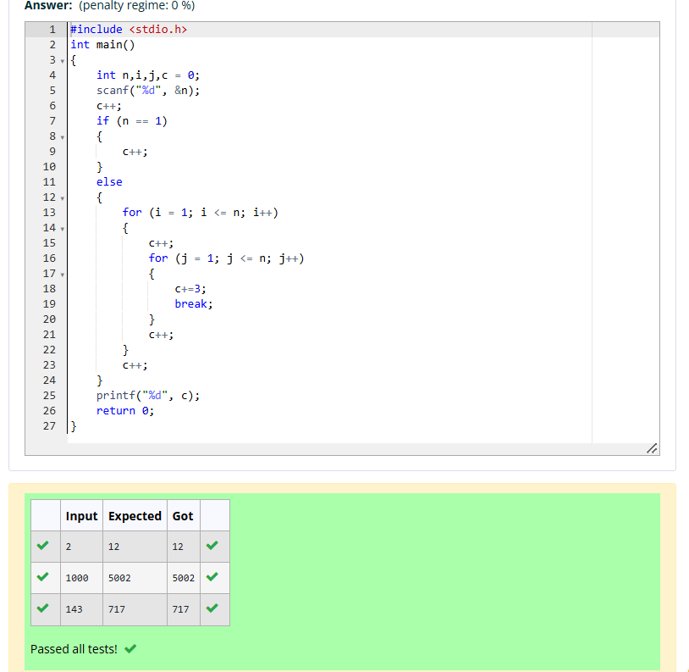

Problem 3: Finding Complexity using Counter Method
Convert the following algorithm into a program and find its time complexity using counter method.
Factor(num) {
{
for (i = 1; i <= num;++i)
{
if (num % i== 0)
{
printf("%d ", i);
}
}
}
Note: No need of counter increment for declarations and scanf() and counter variable printf() statement.
Input:
A positive Integer n
Output:
Print the value of the counter variable
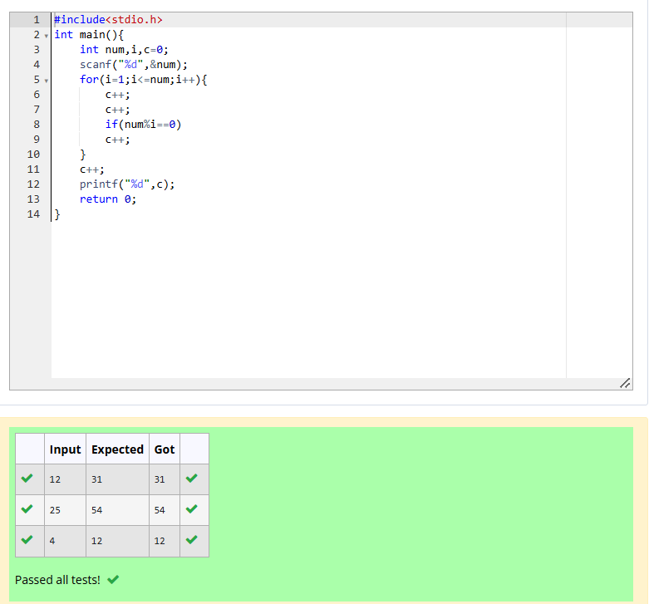

Problem 4: Finding Complexity using Counter Method
Convert the following algorithm into a program and find its time
complexity using counter method.
void function(int n)
{
int c= 0;
for(int i=n/2; i<n; i++)
for(int j=1; j<n; j = 2 * j)
for(int k=1; k<n; k = k * 2)
c++;
}
Note: No need of counter increment for declarations and scanf() and count variable printf() statements.
Input:
A positive Integer n
Output:
Print the value of the counter variable

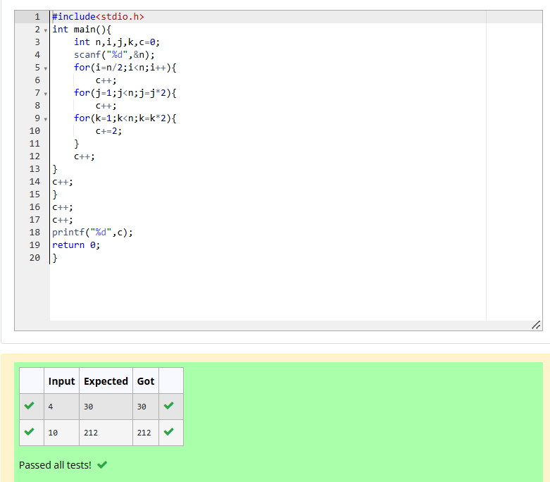

Problem 5: Finding Complexity using counter method
Convert the following algorithm into a program and find its time complexity using counter method.
void reverse(int n)
{
int rev = 0, remainder;
while (n != 0)
{
remainder = n % 10;
rev = rev * 10 + remainder;
n/= 10;
}
print(rev);
}
Note: No need of counter increment for declarations and scanf() and count variable printf() statements.
Input:
A positive Integer n
Output:
Print the value of the counter variable
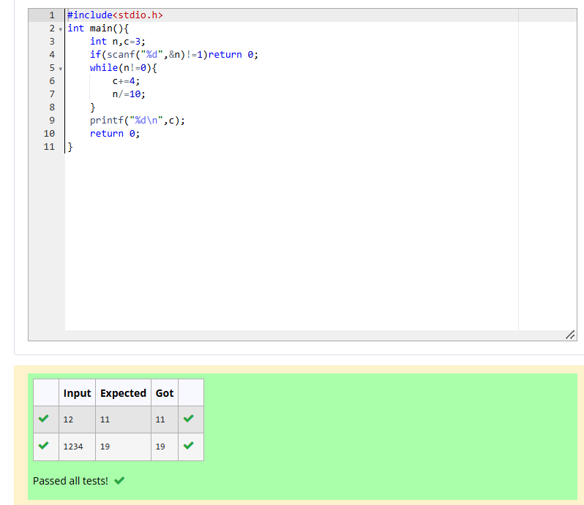

GREEDY ALGORITHMS

1-G-Coin Problem
Write a program to take value V and we want to make change for V Rs, and we have infinite supply of each of the denominations in Indian currency, i.e., we have infinite supply of { 1, 2, 5, 10, 20, 50, 100, 500, 1000} valued coins/notes, what is the minimum number of coins and/or notes needed to make the change.
Input Format:
Take an integer from stdin.
Output Format:
print the integer which is change of the number.
Example Input :
64
Output:
4
Explanaton:
We need a 50 Rs note and a 10 Rs note and two 2 rupee coins.
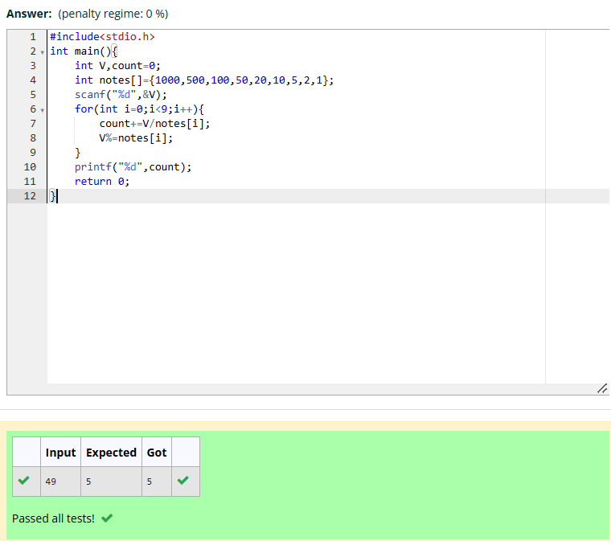

2-G-Cookies Problem
Assume you are an awesome parent and want to give your children some cookies. But, you should give each child at most one cookie.
Each child i has a greed factor g[i], which is the minimum size of a cookie that the child will be content with; and each cookie j has a size s[j]. If s[j] >= g[i], we can assign the cookie j to the child i, and the child i will be content. Your goal is to maximize the number of your content children and output the maximum number.
Example 1:
Input:
3
1 2 3
2
1 1
Output:
1
Explanation: You have 3 children and 2 cookies. The greed factors of 3 children are 1, 2, 3.
And even though you have 2 cookies, since their size is both 1, you could only make the child whose greed factor is 1 content.
You need to output 1.
Constraints:
1 <= g.length <= 3 * 10^4
0 <= s.length <= 3 * 10^4
1 <= g[i], s[j] <= 2^31 - 1
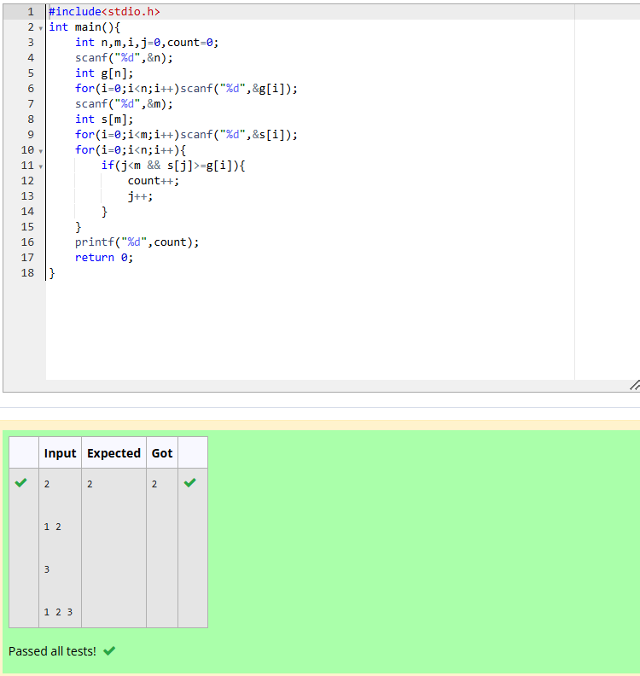

3-G-Burger Problem
A person needs to eat burgers. Each burger contains a count of calorie. After eating the burger, the person needs to run a distance to burn out his calories.
If he has eaten i burgers with c calories each, then he has to run at least 3^{i} * c kilometers to burn out the calories. For example, if he ate 3
burgers with the count of calorie in the order: [1, 3, 2], the kilometers he needs to run are (3⁰ * 1) + (3¹ * 3) + (3² * 2) = 1 + 9 + 18 = 28.
But this is not the minimum, so need to try out other orders of consumption and choose the minimum value. Determine the minimum distance
he needs to run. Note: He can eat burger in any order and use an efficient sorting algorithm.Apply greedy approach to solve the problem.
Input Format
First Line contains the number of burgers
Second line contains calories of each burger which is n space-separate integers
Output Format
Print: Minimum number of kilometers needed to run to burn out the calories
Sample Input
3
5 10 7
Sample Output
76

For example:
Test | Input | Result
Test Case 1 | 3  1 3 2 | 18

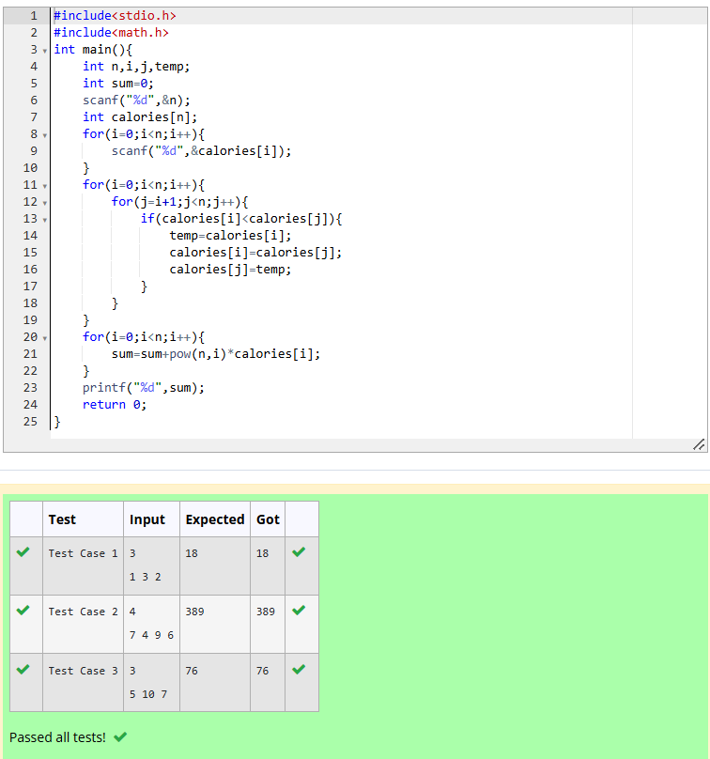

4-G-Array Sum max problem
Given an array of N integer, we have to maximize the sum of arr[i] * i, where i is the index of the element (i = 0, 1, 2, ..., N).Write an algorithm based on Greedy technique with a Complexity O(nlogn).
Input Format:
First line specifies the number of elements-n
The next n lines contain the array elements.
Output Format:
Maximum Array Sum to be printed.
Sample Input:
5
2 5 3 4 0
Sample output:
40
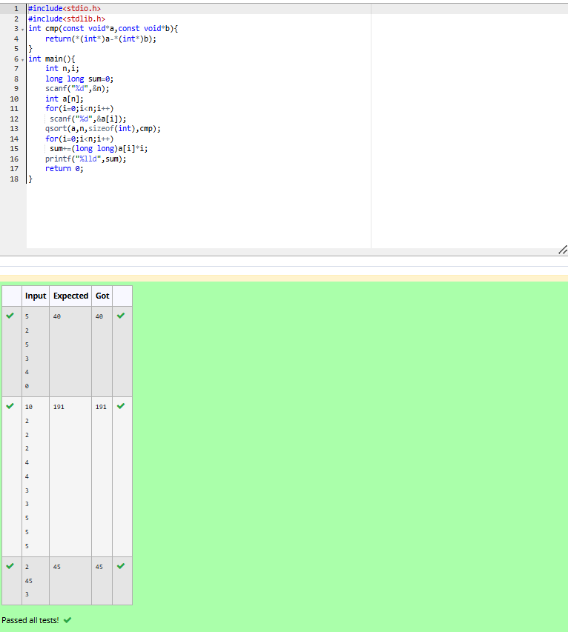

5-G-Product of Array elements-Minimum
Given two arrays array_One[] and array_Two[] of same size N. We need to first rearrange the arrays such that the sum of the product of pairs( 1 element from each) is minimum. That is SUM (A[i] * B[i]) for all i is minimum.
For example:
Input | Result
3  1  2  3  4  5  6 | 28
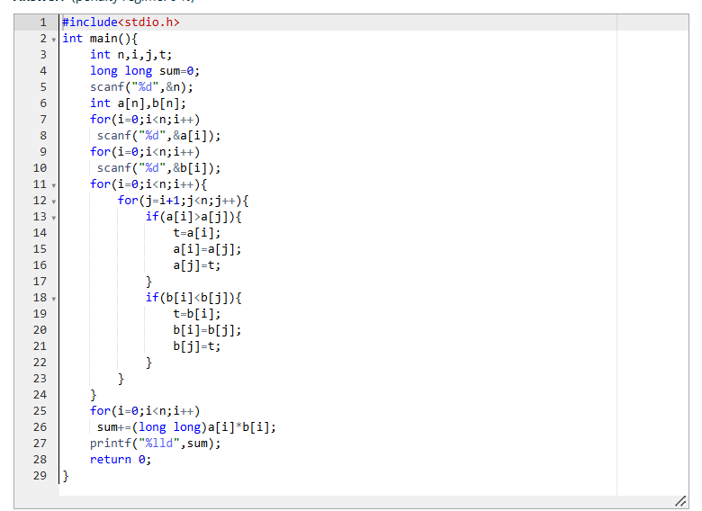
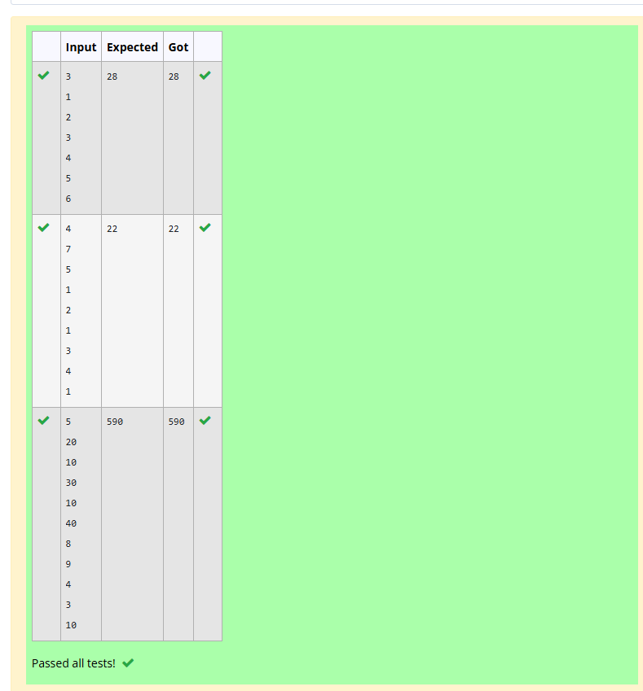

DIVIDE AND CONQUER

1-Number of Zeros in a Given Array
Problem Statement
Given an array of 1s and 0s this has all 1s first followed by all 0s. Aim is to find the number of 0s. Write a program using Divide and Conquer to Count the number of zeroes in the given array.
Input Format
First Line Contains Integer m – Size of array
Next m lines Contains m numbers – Elements of an array
Output Format
First Line Contains Integer – Number of zeroes present in the given array.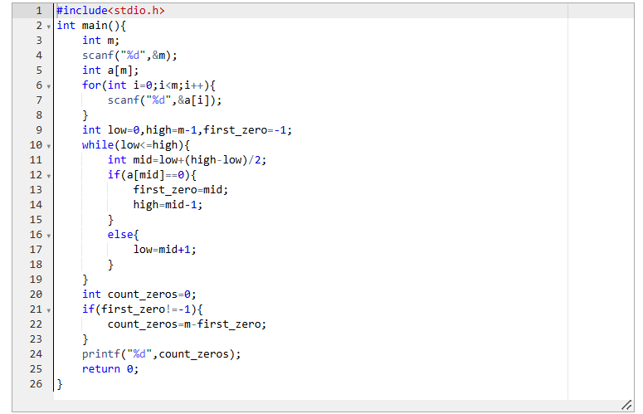
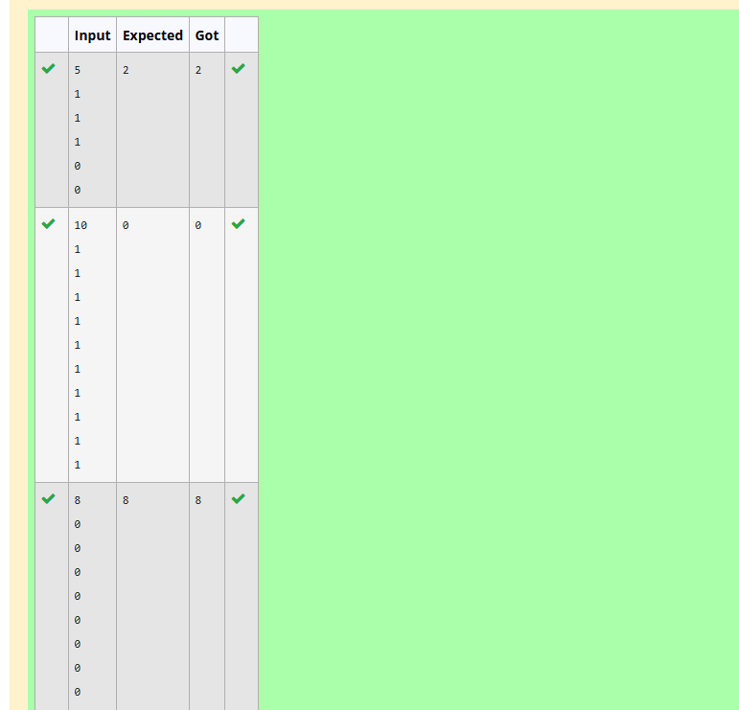

2-Majority Element
Given an array nums of size n, return the majority element.
The majority element is the element that appears more than ⌊n / 2⌋ times. You may assume that the majority element always exists in the array.

Example 1:
Input: nums = [3,2,3]
Output: 3
Example 2:
Input: nums = [2,2,1,1,1,2,2]
Output: 2

Constraints:
- n == nums.length
- 1 <= n <= 5 * 10⁴
- -2³¹ <= nums[i] <= 2³¹ - 1

For example:
Input | Result
3  3 2 3 | 3
7  2 2 1 1 1 2 2 | 2
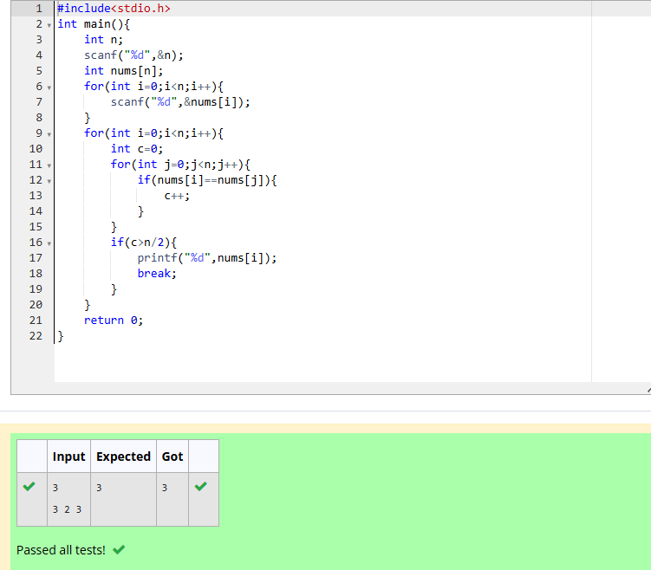

3-Finding Floor Value
Problem Statement:
Given a sorted array and a value x, the floor of x is the largest element in array smaller than or equal to x. Write divide and conquer algorithm to find floor of x.
Input Format
First Line Contains Integer n – Size of array
Next n lines Contains n numbers – Elements of an array
Last Line Contains Integer x – Value for x
Output Format
First Line Contains Integer – Floor value for x
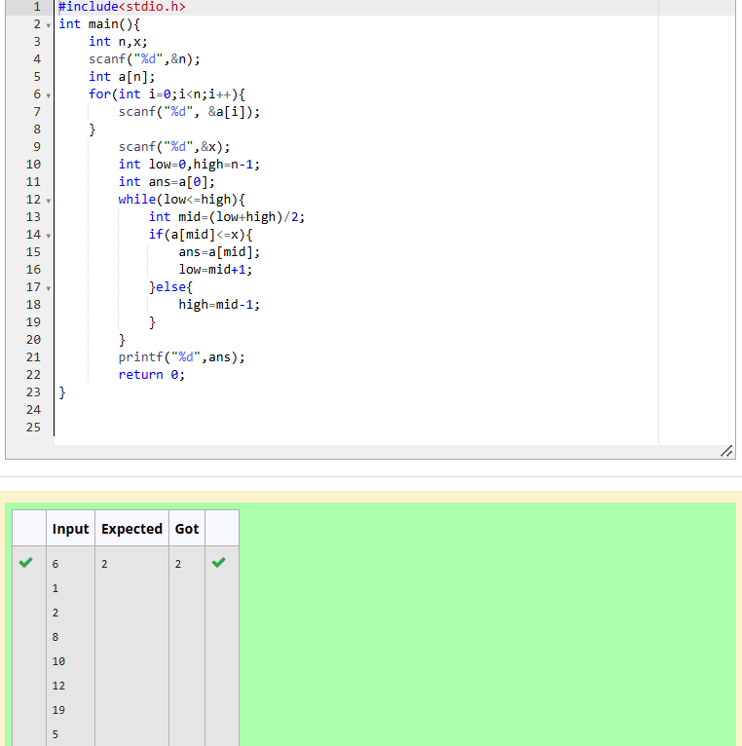
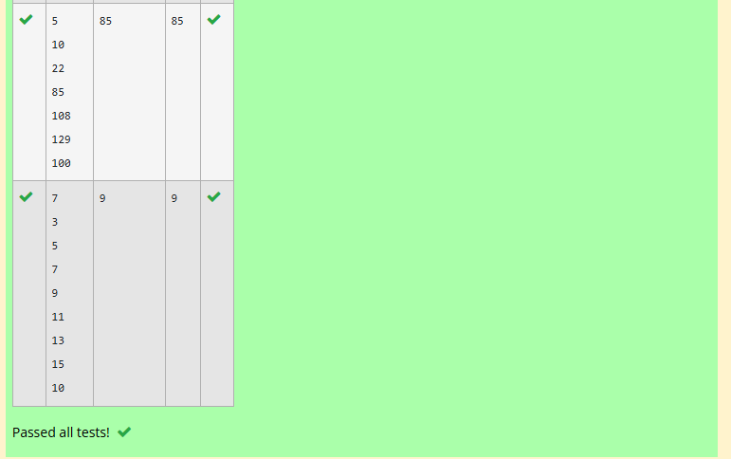

4-Two Elements sum to x
Problem Statement:
Given a sorted array of integers say arr[] and a number x. Write a recursive program using divide and conquer strategy to check if there exist two elements in the array whose sum = x. If there exist such two elements then return the numbers, otherwise print as “No”.
Note: Write a Divide and Conquer Solution
Input Format
First Line Contains Integer n – Size of array
Next n lines Contains n numbers – Elements of an array
Last Line Contains Integer x – Sum Value
Output Format
First Line Contains Integer – Element1
Second Line Contains Integer – Element2 (Element 1 and Elements 2 together sums to value “x”)
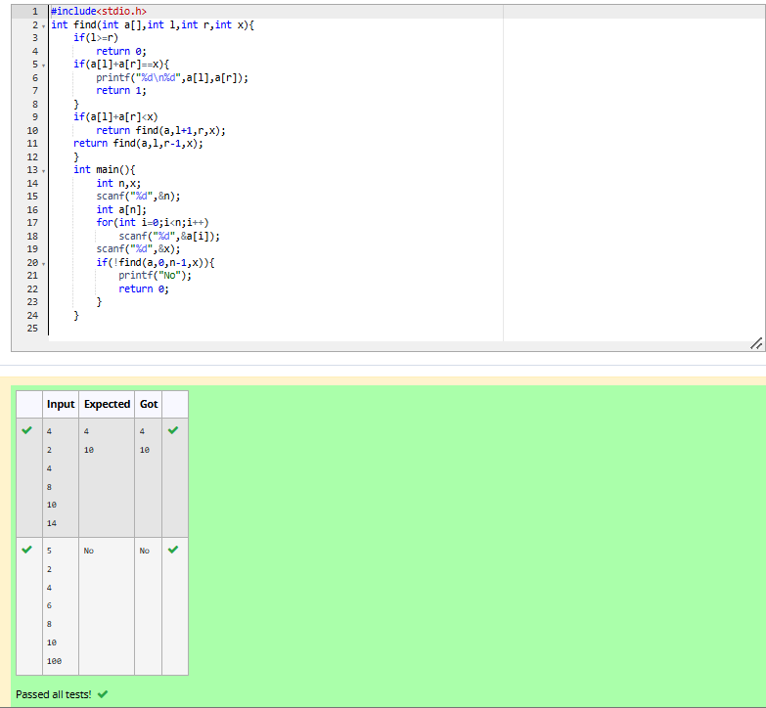

5-Implementation of Quick Sort
Write a Program to Implement the Quick Sort Algorithm
Input Format:
The first line contains the no of elements in the list-n
The next n lines contain the elements.
Output:
Sorted list of elements
For example:
Input | Result
5  67 34 12 98 78 | 12 34 67 78 98

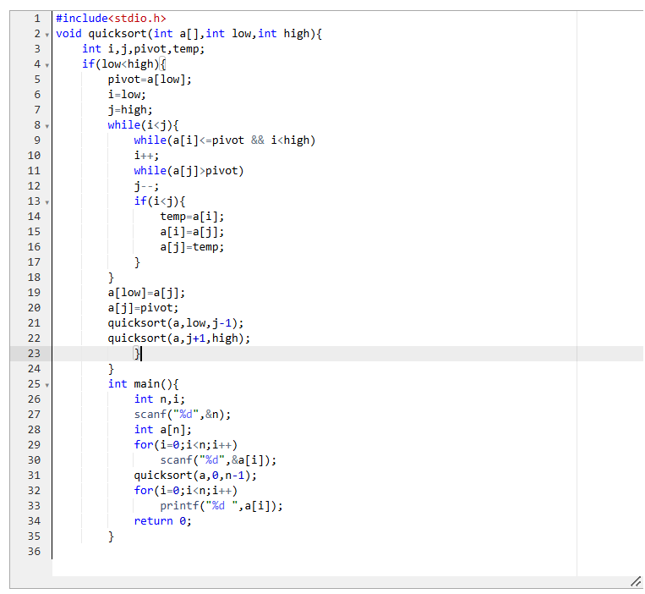
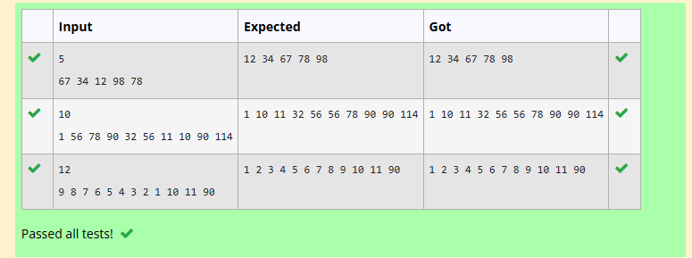

DYNAMIC PROGRAMMING

1-DP-Playing with Numbers
Playing with Numbers:
Ram and Sita are playing with numbers by giving puzzles to each other. Now it was Ram term, so he gave Sita a positive integer ‘n’ and two numbers 1 and 3. He asked her to find the possible ways by which the number n can be represented using 1 and 3.Write any efficient algorithm to find the possible ways.
Example 1:
Input: 6
Output:6
Explanation: There are 6 ways to 6 represent number with 1 and 3
1+1+1+1+1+1
3+3
1+1+1+3
1+1+3+1
1+3+1+1
3+1+1+1
Input Format
First Line contains the number n
Output Format
Print: The number of possible ways ‘n’ can be represented using 1 and 3
Sample Input
6
Sample Output
6
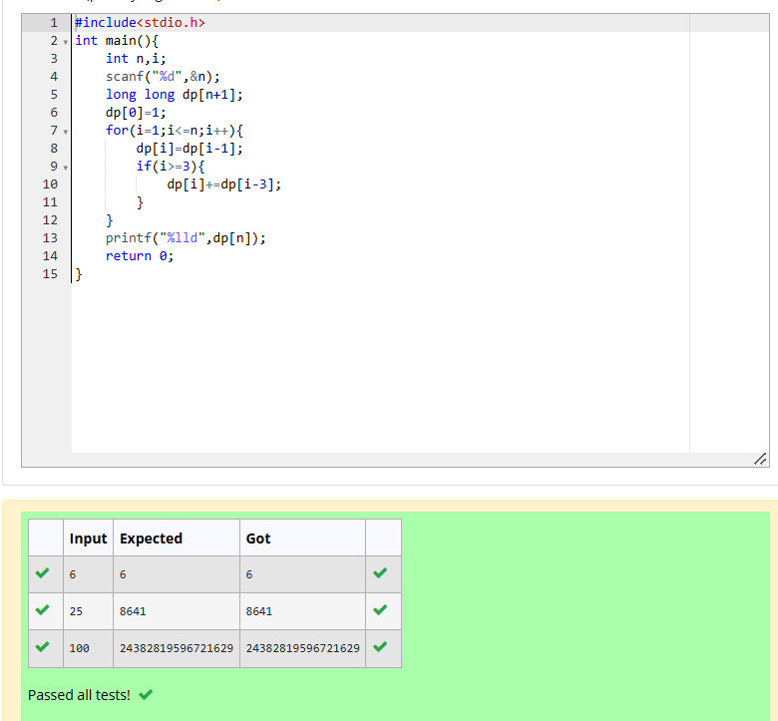

2-DP-Playing with chessboard
Playing with Chessboard:
Ram is given with an n*n chessboard with each cell with a monetary value. Ram stands at the (0,0), that the position of the top left white rook. He is been given a task to reach the bottom right black rook position (n-1, n-1) constrained that he needs to reach the position by traveling the maximum monetary path under the condition that he can only travel one step right or one step down the board. Help ram to achieve it by providing an efficient DP algorithm.
Example:
Input
3
1 2 4
2 3 4
8 7 1
Output:
19
Explanation:
Totally there will be 6 paths among that the optimal is
Optimal path value:1+2+8+7+1=19
Input Format
First Line contains the integer n
The next n lines contain the n*n chessboard values
Output Format
Print Maximum monetary value of the path
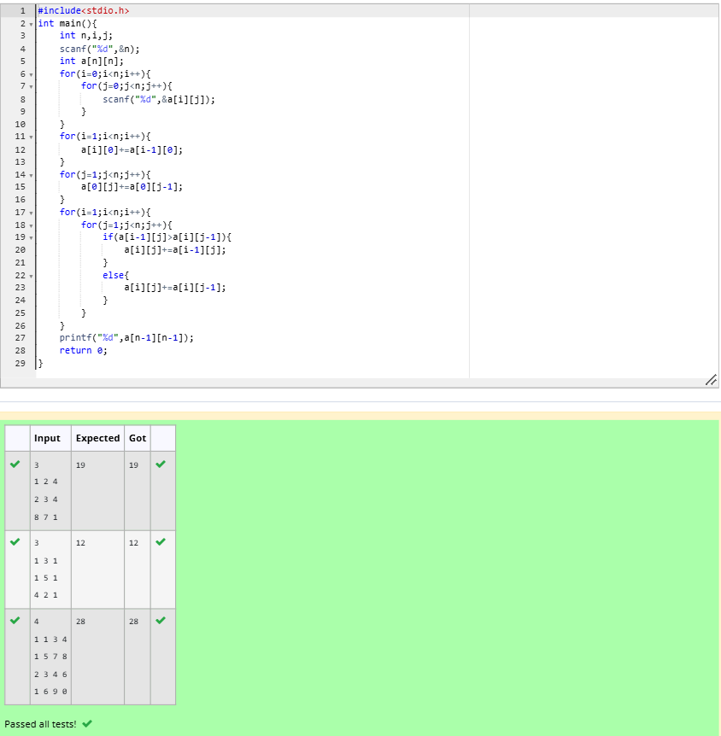

3-DP-Longest Common Subsequence
Given two strings find the length of the common longest subsequence(need not be contiguous) between the two.

Example:
s1: ggtabe
s2: tgatasb

s1 |  | a | g | g | t | a | b
s2 |  | g | x | t | x | a | y | b

The length is 4
Solveing it using Dynamic Programming
For example:
Input | Result
aab  azb | 2
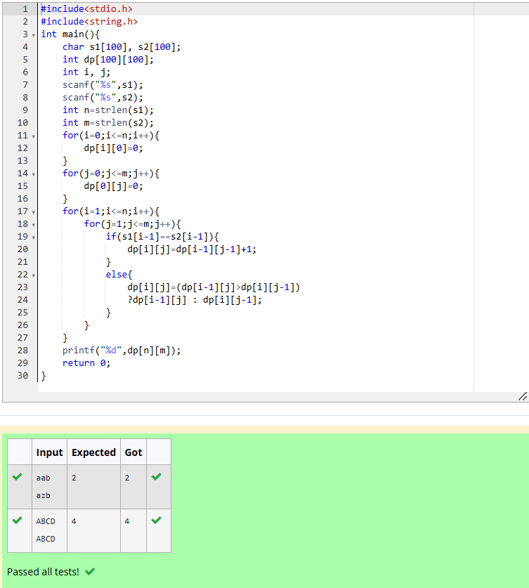

4-DP-Longest non-decreasing Subsequence
Problem statement:
Find the length of the Longest Non-decreasing Subsequence in a given Sequence.
Eg:

Input:9
Sequence:[-1,3,4,5,2,2,2,2,3]
the subsequence is [-1,2,2,2,2,3]
Output:6
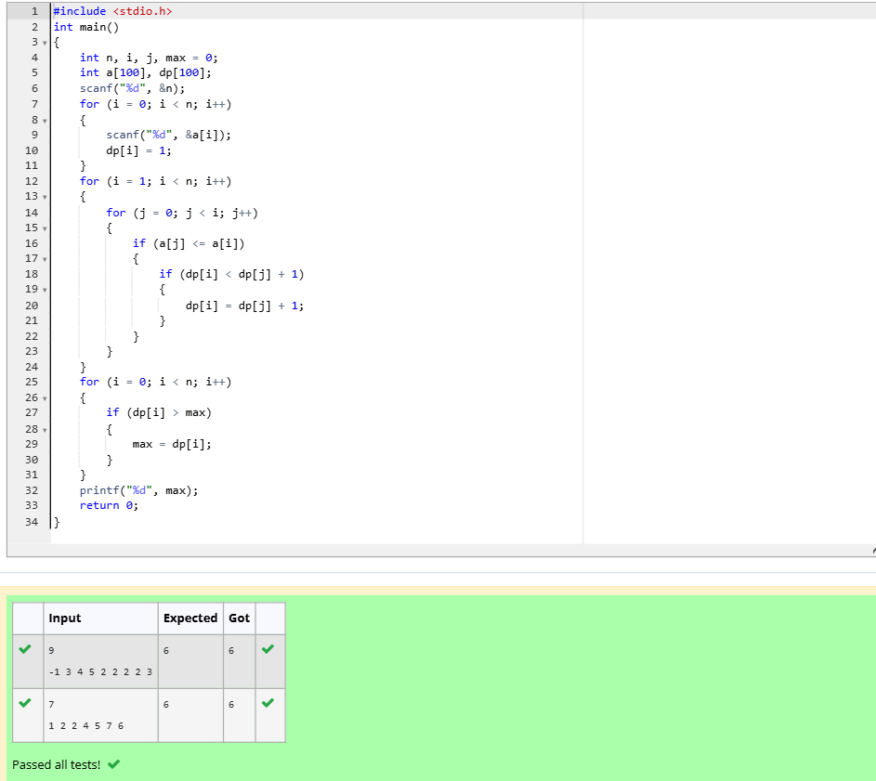

COMPETITIVE PROGRAMMING

1-Finding Duplicates-O(n^2) Time Complexity,O(1) Space Complexity
Find Duplicate in Array.
Given a read only array of n integers between 1 and n, find one number that repeats.
Input Format:
First Line - Number of elements
n Lines - n Elements
Output Format:
Element x - That is repeated
For example:
Input | Result
5  1 1 2 3 4 | 1
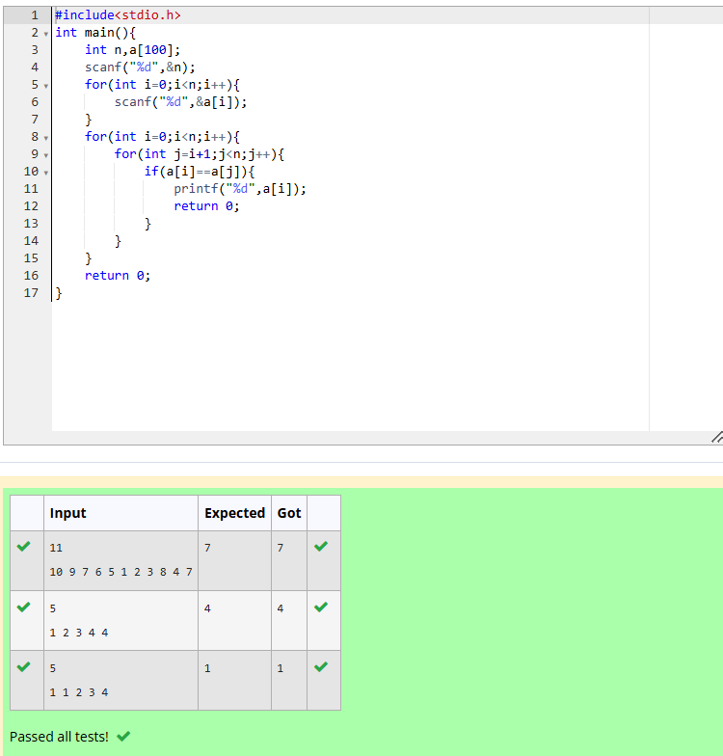

2-Finding Duplicates-O(n) Time Complexity,O(1) Space Complexity
Find Duplicate in Array.
Given a read only array of n integers between 1 and n, find one number that repeats.
Input Format:
First Line - Number of elements
n Lines - n Elements
Output Format:
Element x - That is repeated
For example:
Input | Result
5  1 1 2 3 4 | 1
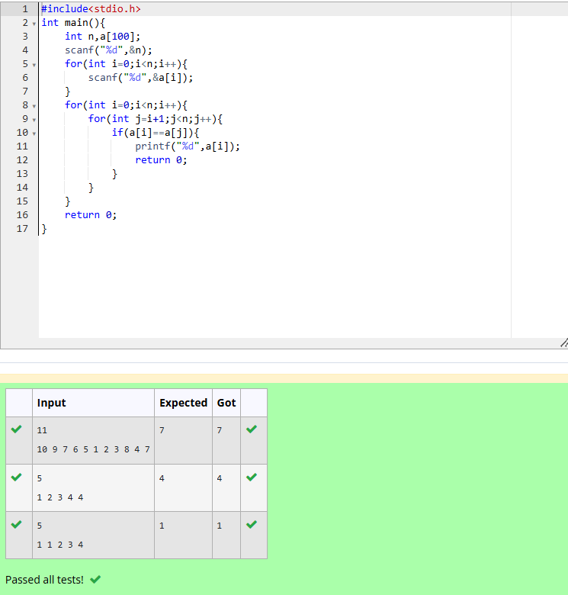

3-Print Intersection of 2 sorted arrays-O(m*n)Time Complexity,O(1) Space Complexity
Find the intersection of two sorted arrays.
OR in other words,
Given 2 sorted arrays, find all the elements which occur in both the arrays.
Input Format
· The first line contains T, the number of test cases. Following T lines contain:
1. Line 1 contains N1, followed by N1 integers of the first array
2. Line 2 contains N2, followed by N2 integers of the second array
Output Format
The intersection of the arrays in a single line
Example
Input:
1
3 10 17 57
6 2 7 10 15 57 246
Output:
10 57
Input:
1
6 1 2 3 4 5 6
2 1 6
Output:
1 6

For example:
Input | Result
1  3 10 17 57  6  2 7 10 15 57 246 | 10 57

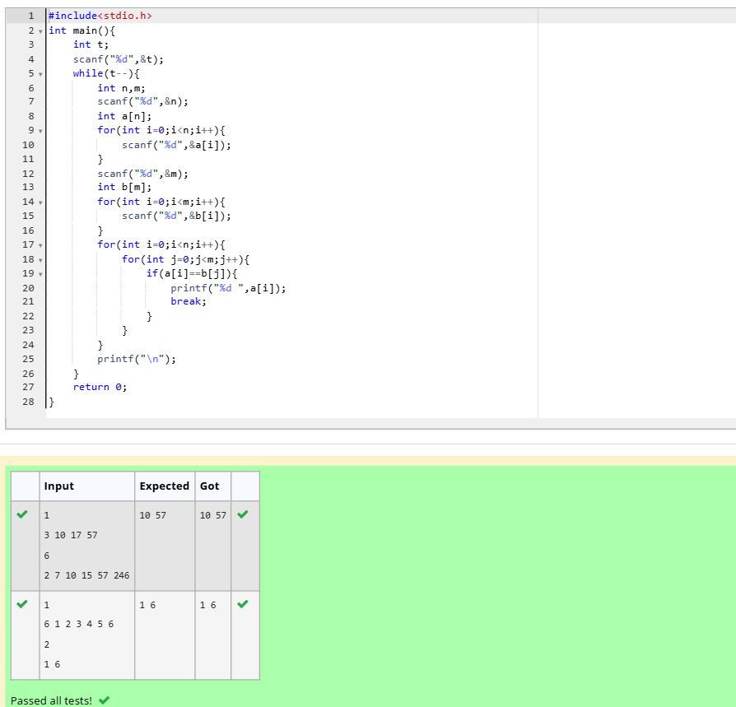

4-Print Intersection of 2 sorted arrays-O(m+n)Time Complexity,O(1) Space Complexity
Find the intersection of two sorted arrays.
OR in other words,
Given 2 sorted arrays, find all the elements which occur in both the arrays.
Input Format
· The first line contains T, the number of test cases. Following T lines contain:
1. Line 1 contains N1, followed by N1 integers of the first array
2. Line 2 contains N2, followed by N2 integers of the second array
Output Format
The intersection of the arrays in a single line
Example
Input:
1
3 10 17 57
6 2 7 10 15 57 246
Output:
10 57
Input:
1
6 1 2 3 4 5 6
2 1 6
Output:
1 6

For example:
Input | Result
1  3 10 17 57  6  2 7 10 15 57 246 | 10 57

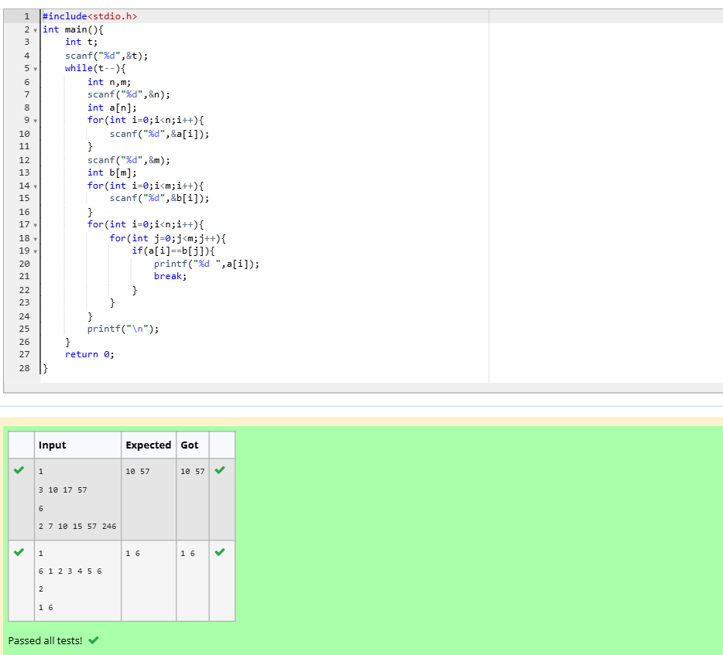

5-Pair with Difference-O(n^2)Time Complexity,O(1) Space Complexity
Given an array A of sorted integers and another non negative integer k, find if there exists 2 indices i and j such that A[j] - A[i] = k, i != j.
Input Format:
First Line n - Number of elements in an array
Next n Lines - N elements in the array
k - Non - Negative Integer
Output Format:
1 - If pair exists
0 - If no pair exists
Explanation for the given Sample Testcase:
YES as 5 - 1 = 4
So Return 1.

For example:
Input | Result
3  1 3 5  4 | 1

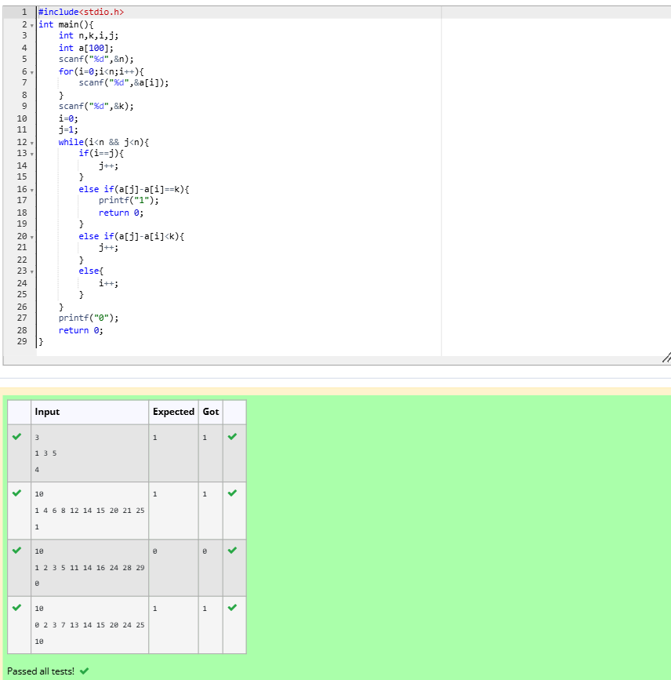

6-Pair with Difference -O(n) Time Complexity,O(1) Space Complexity
Given an array A of sorted integers and another non negative integer k, find if there exists 2 indices i and j such that A[j] - A[i] = k, i != j.
Input Format:
First Line n - Number of elements in an array
Next n Lines - N elements in the array
k - Non - Negative Integer
Output Format:
1 - If pair exists
0 - If no pair exists
Explanation for the given Sample Testcase:
YES as 5 - 1 = 4
So Return 1.

For example:
Input | Result
3  1 3 5  4 | 1


